
Yr 9 - Pythagoras Investigation 2018
Name:______________________
/29 marks
Time: 50min
Part A – Collaborative Section
Below is a right angled triangle, with the two sides being 3 cm (side “a”) and 4 cm long (side”b”).

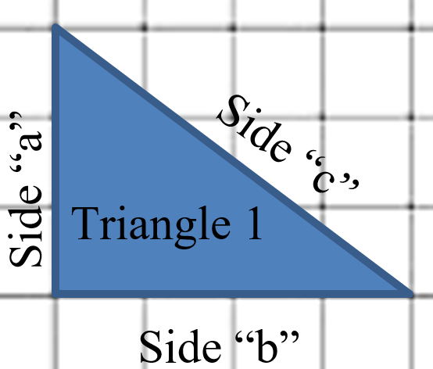

The longest in a right angled triangle has a special name. it is called a “Hypotenuse”.

Question 1.
(1 mark)
On the diagram above – label Side “c” with the word hypotenuse.

Question 2
(1 mark)
Measure the 3rd side (side “c”), and record it in the table below.

Triangle | Side a | Side b | Side c
1 | 3 | 4

From this triangle make one square using the length of side “a” (3cm) and a second square with the length of side “b” (4cm).


4 cm
3 cm
3 cm

4 cm

Using the formula “Area = length x width” we can calculate the area of these squares.

Area of the square made using side a = 3 x 3
= 3²
= 9

Area of the square made using side b = 4 x 4
= 4²
= 16

Question 3
(1 mark)
What is the value of these areas added together?

Question 4
(1 mark)
Add this value to the table below in the column a² + b².

Question 5
(1 mark)
What is the area of the square made using the length of side “c”?

Triangle | Area of square made from side a =  $a×a=$a² | Area of square made from side b =  $b×b=$b² | a² + b² | Area of square made from side c =  $c×c=$c²
1 | 9 | 16

(1 mark)
Question 6
What do you notice about your answer for a² + b² and also for the area of the square of side “c”?

(3 marks)
Question 7.
Draw 3 more right angled triangles of different sizes on the squared paper provided.
(3 marks)
Question 8.
The longest side, (opposite the right angle) is called the hypotenuse – for each of your triangles label the hypotenuse side “c” and the other 2 sides “a” and “b” (which is “a” and which is “b” isn’t important as long as “c” is the hypotenuse).
(3 marks)
Question 9.
For each of the 3 new triangles you have drawn, measure the lengths of the sides and record those measurements in the table below.

Triangle | Side a | Side b | Side c
1
2
3
(3 marks)
Question 10.
Using the same method we used earlier, for each of your 3 new triangles, find the area of the squares made using the length of sides “a” and “b” and write these values into the table below.

Triangle | Area of square made from side a =  $a×a=$a² | Area of square made from side b =  $b×b=$b² | a² + b² | Area of square made from side c =  $c×c=$c²
1
2
3

(3 marks)
Question 11.
For each of your triangles, calculate the value of the 2 smaller areas added together and add them to the table above (a² + b²).

(3 marks)
Question 12.
For each of your triangles, calculate the area of the square made using the length of side “c”. Add this value to the same table you used for the last 2 questions.

Question 13.
(2 marks)
What do you notice about the last 2 columns?

(3 marks)
Question 14.
Can you write an equation linking a², b² and c²?

_____________ = _____________

End of investigation

